# BUILD AN EMPLOYEE TRAVEL APPROVAL APPLICATION FOR CORPORATES

Project Presented By

Team ID : NM2023TMID20336

Team Leader : KAVIPRIYA P

Team members : RUBASRI. S

PRADEEPA. N

PAVITHRA. P

**INTRODUCTION**

* **Overview**

*Corporate travel is an integral part of the business world, as companies need to travel to meet clients, attend conferences and meetings, and explore new markets. However, managing employee travel can be a cumbersome task for the HR and travel departments. That’s why many corporates have started using employee travel approval applications to streamline the process.*

* **Purpose**

*The application saves time for both the employee and the travel manager by automating the travel request and approval process. The application ensures that travel requests comply with the company’s travel policies, which reduces the risk of non- compliant expenses and unnecessary travel.*

* ***Result***

***Data model***

|  |  |  |  |  |  |  |  |  |  |  |  |  |  |  |  |  |  |  |  |
| --- | --- | --- | --- | --- | --- | --- | --- | --- | --- | --- | --- | --- | --- | --- | --- | --- | --- | --- | --- |
| ***Object Name***   |  | | --- | |  | | *Travel Approval* | | *Formula Field* | | *Status _Indicator* | | ***Fields in the Object***   |  |  | | --- | --- | | ***Field label*** | ***Data type*** | | *Amount* | *Currency* | | *Expense Type Field* | *Pick list* | | *Travel Approval field* | *Master -Detail Relationship* | | *Total Expenses* | *Roll-Up Summary* | | *Status Images* | *Formula* | | *Status Indicator* | *Text* | |

***Activity and screenshot***

***Create Salesforce Organization***

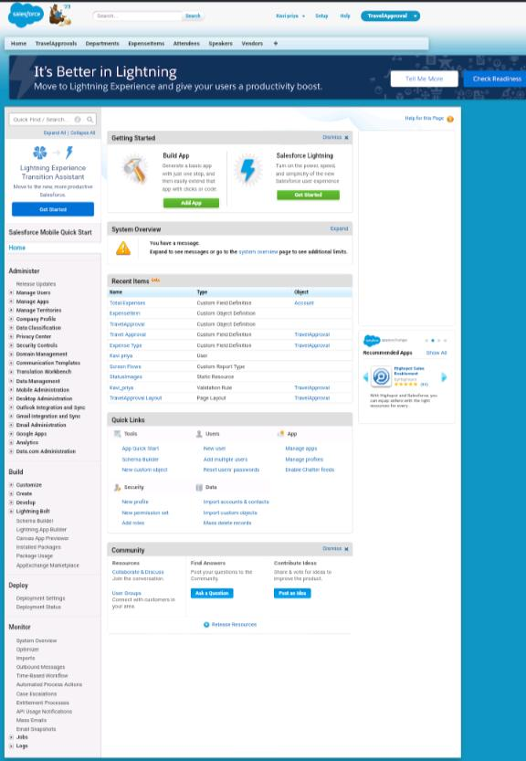

***Account Activation***

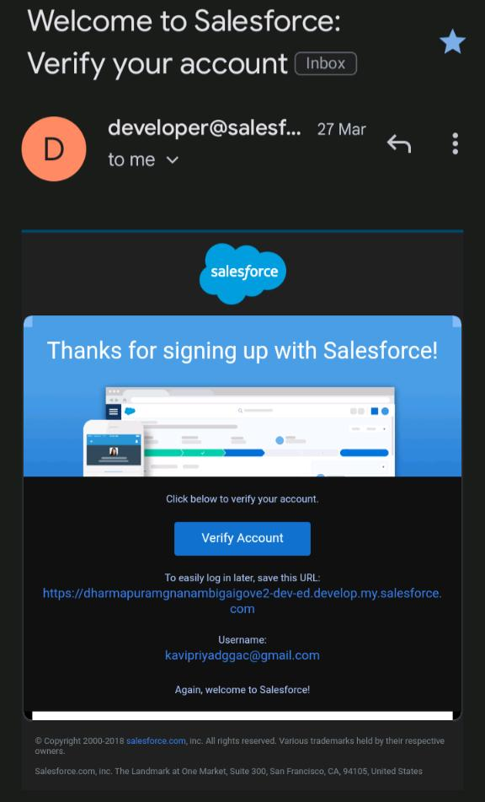

***Creating the Application***

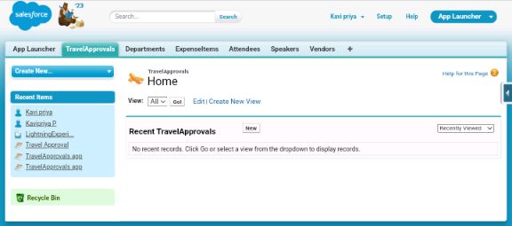

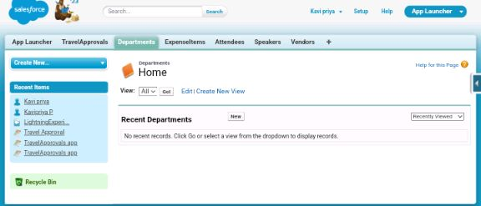

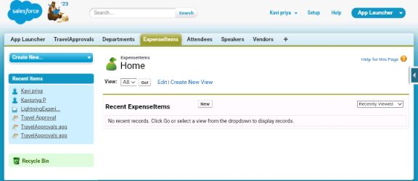

***Custom Object Creation***

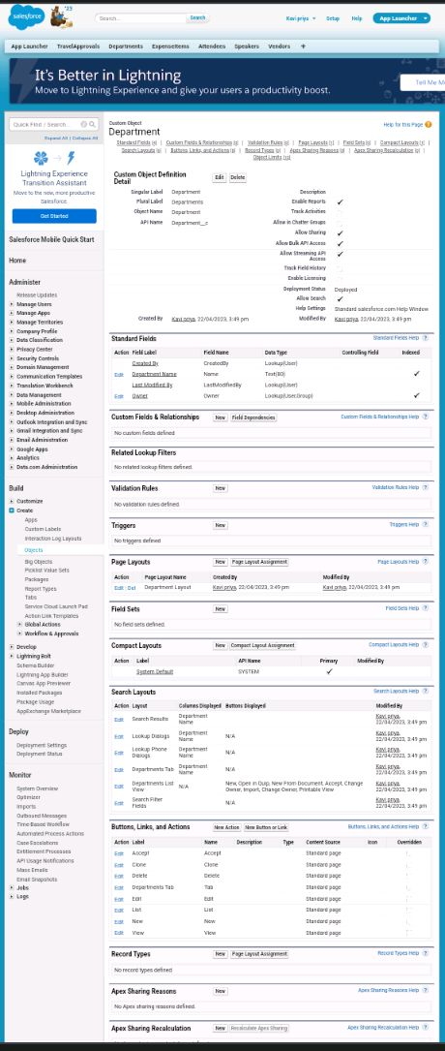

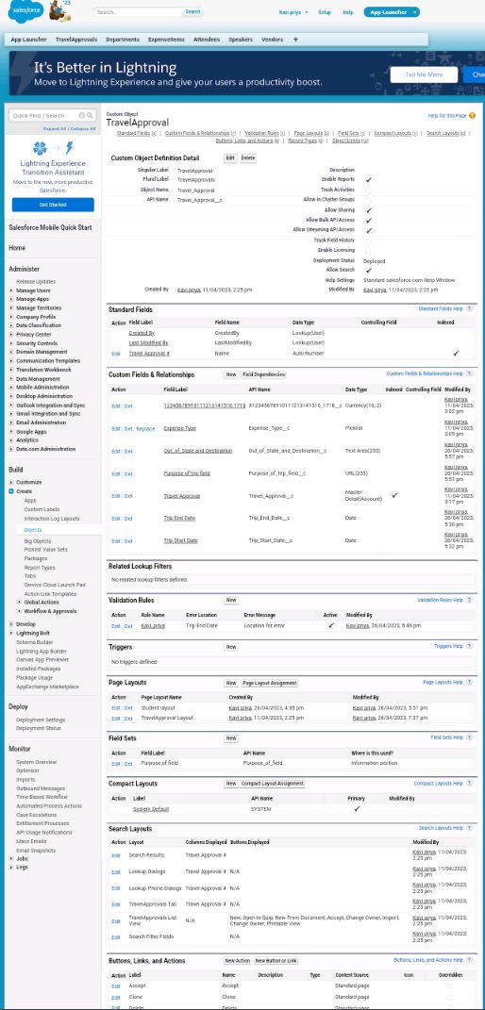

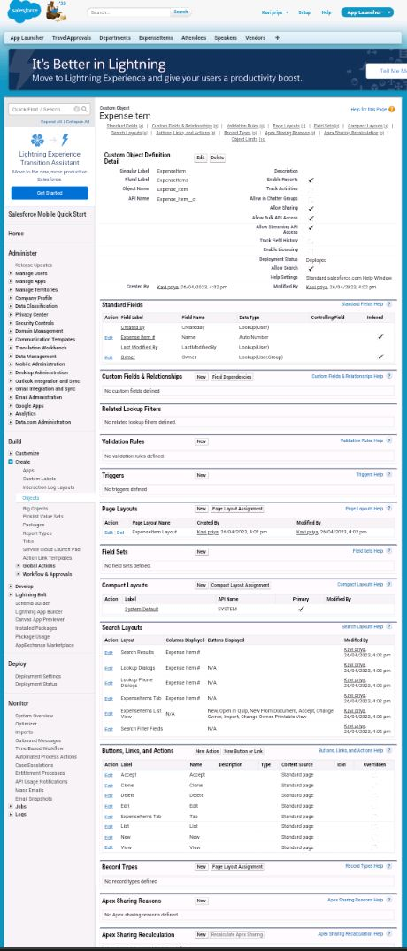

***Tab***

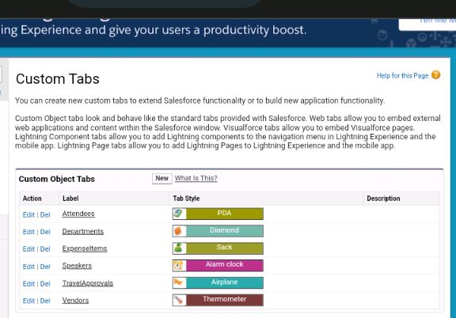

*Create field and relationships*

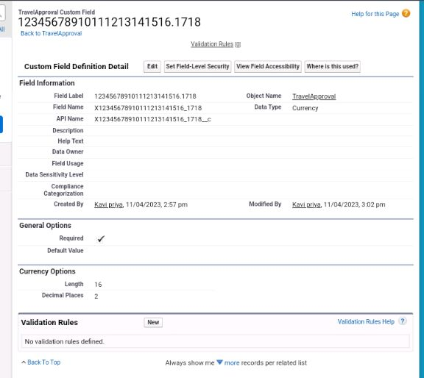

*Create the Expense Type field*

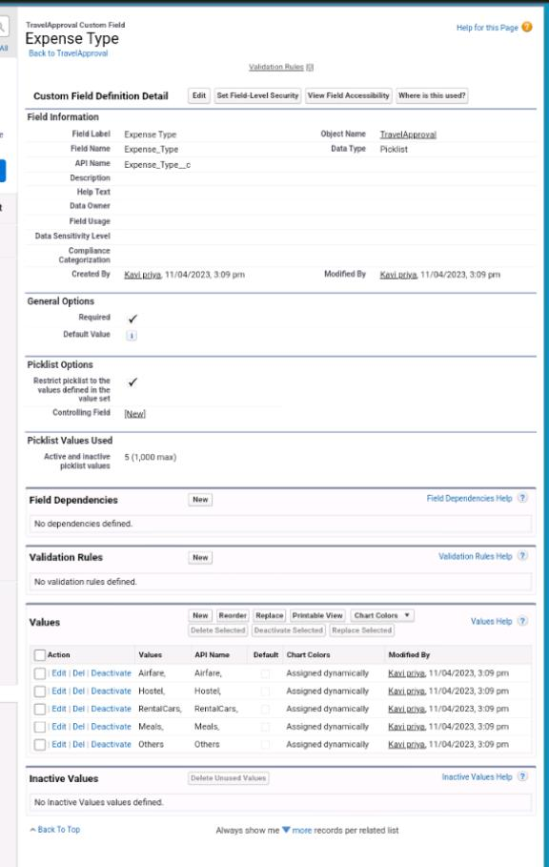

*Create the Travel Approval field*

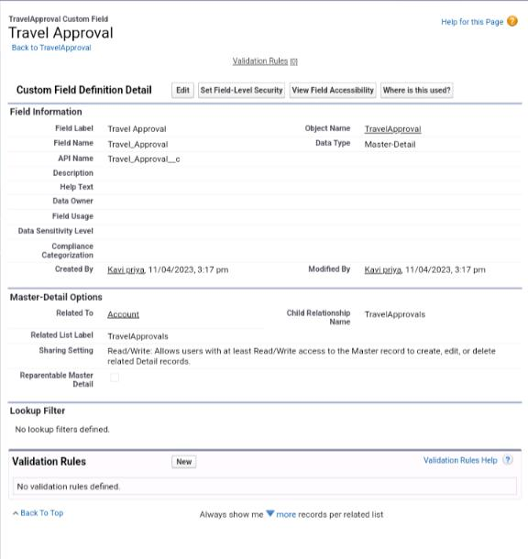

*Import Department*

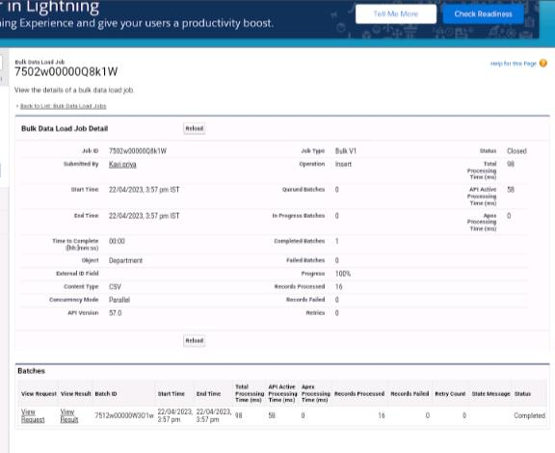

***Customize User Interface***

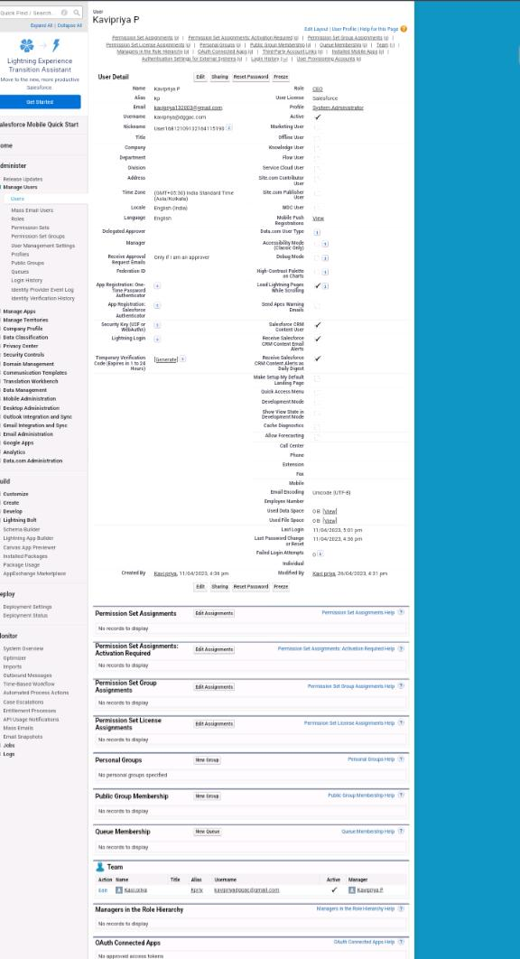

*Use customisation*

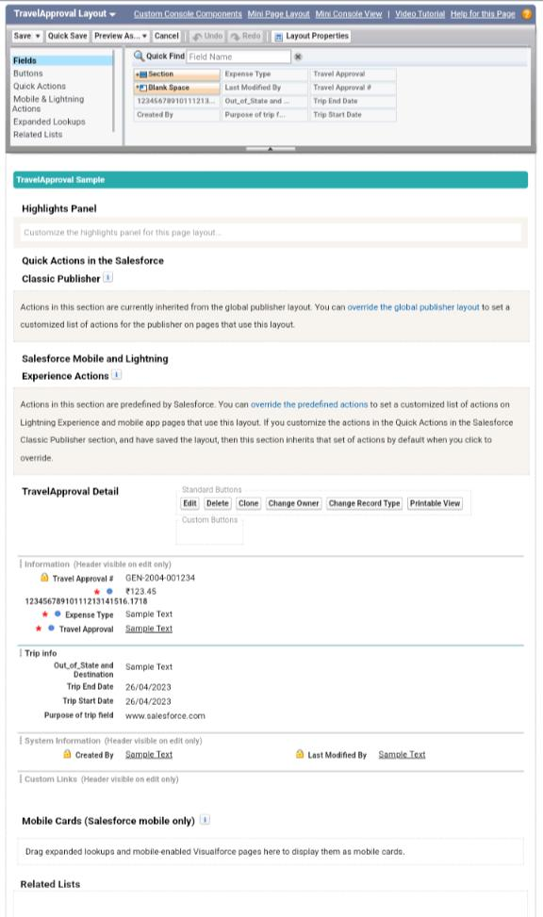

*Add Business Logic to Travel App*

1. *Create Validation Rule*

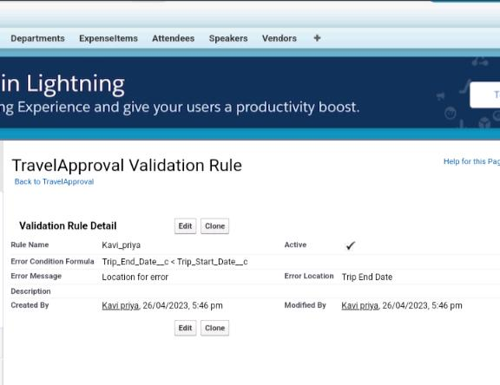

1. *Create RollUp Summary Field*

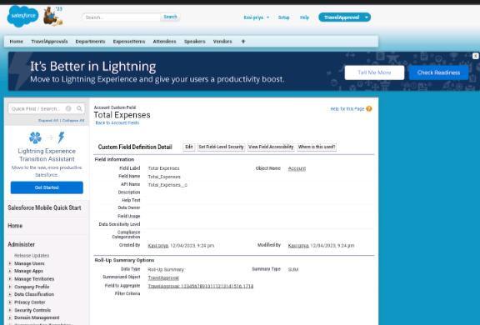

1. *Create Formula Fields*

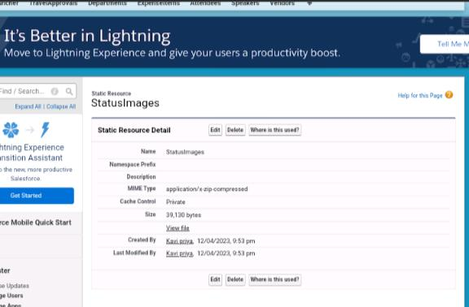

*Report*

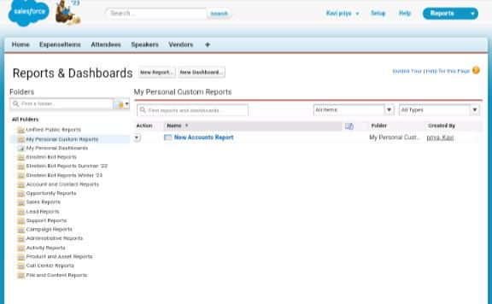

*Dashboard 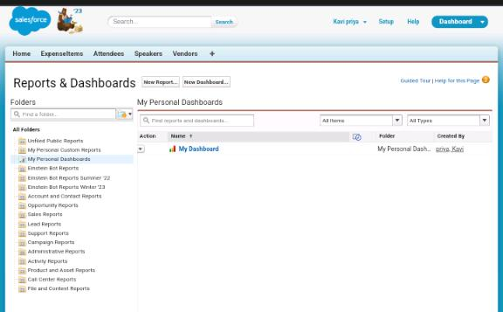*

*TRAILHEAD PROFILE PUBLIC URL*

*Team Leader:*

[*https://trailblazer.me/id/kavipriya244*](https://trailblazer.me/id/kavipriya244)

*Team Member 1:*

[*https://trailblazer.me/id/ssureshmoorthip*](https://trailblazer.me/id/ssureshmoorthip)

*Team Member 2:*

[*https://trailblazer.me/id/pnagarajanb*](https://trailblazer.me/id/pnagarajanb)

*Team Member 3:*

[*https://trailblazer.me/id/pavip28*](https://trailblazer.me/id/pavip28)

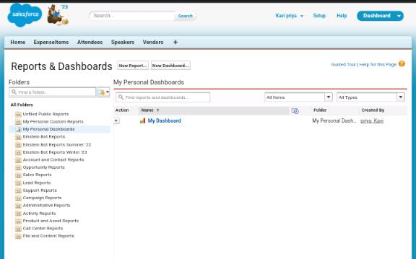

* **Advantages**

1. *The process is tedious and time- consuming task*
2. *Easiest way*
3. *Saves time for both employees and managers*
4. *Reduces the workload*
5. *The entire process is digitized and streamlined*
6. *Increased Transparency*
7. *Provides greater control and security over employee travel*

* **DISADVANTAGES**

1. *The process includes too many levels of approval that make tedious and confusing*
2. *Regular Maintenance*
3. *Internet Connection problem is there*
4. *Poor Connection leads to trouble and anxiety*
5. *Lack of leadership*
6. *It can be costly sometimes*
7. *Poor communication*

* **APPLICATIONS**

*The application ensures that travel requests comply with the company’s travel policies which reduces the risk of non-complaint expenses and unnecessary travel. The application helps reduce travel costs by allowing the company to track expenses and stay within budget. This also helps the company negotiate better deals with travel vendors. The application saves time for both the employee and the travel manager by automating the travel request and approval process. This allows the HR department and travel managers to focus on more strategic tasks.*

* **Conclusion**

*An employee travel approval application is a valuable tool for corporate travel management. It streamlines the travel request and approval process ensures policy compliance, and provides transparency to all parties involved. A well-designed application can save time and money, making it an essential tool for corporate that frequently travel for business.*

* ***FUTURE SCOPE***

1. *In future it will be really a useful one in the application of travel approval.*
2. *It is trusted to be in future everyone will utilize this.*
3. *The customer will set good service and make it trustworthy.*
4. *Hope it would fulfil all the needs of the users.*